Tab for the Guest

Materials from the guest (for preparing questions)
These notes help us draft focused questions and an event description.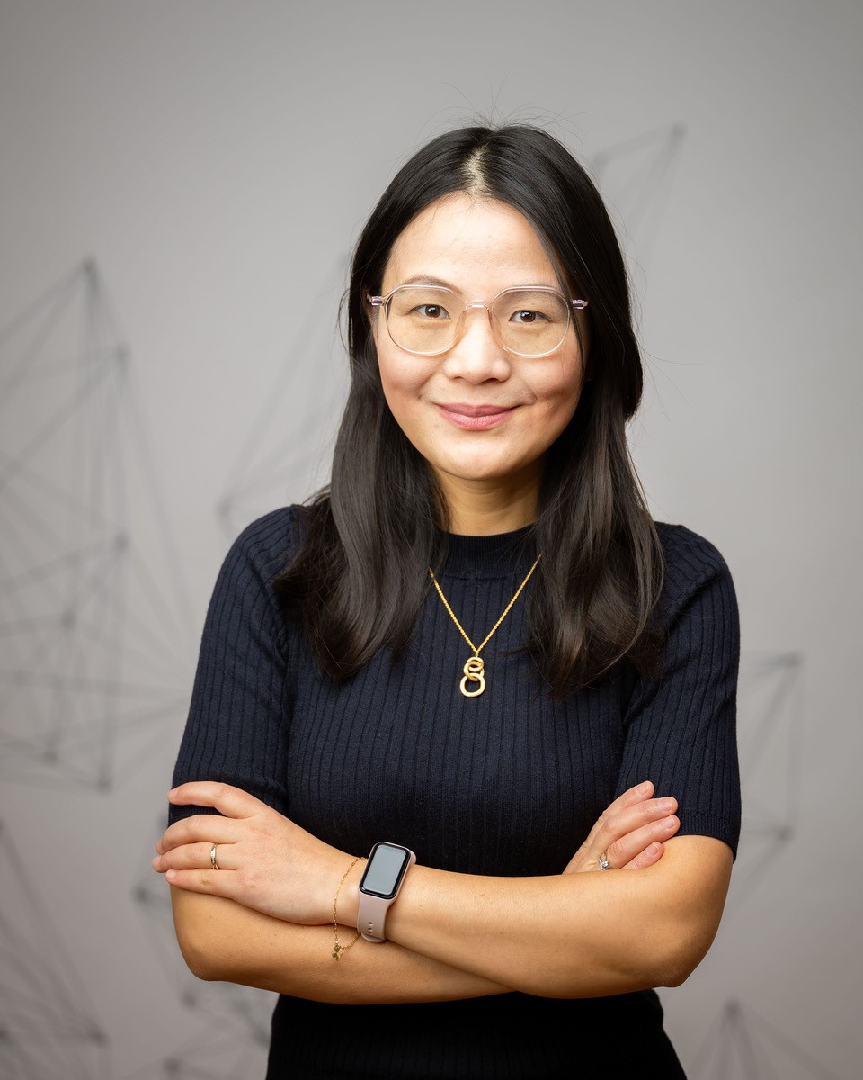

General questions
- How would you like us to introduce you?

- What are you currently focused on—projects or themes you’d enjoy discussing?
  - Stepping into my first leadership role since September this year.
  - Reflections from my first 100 days as Head of Data and Cloud—what I’ve learned, challenges faced, and how I’m growing into this role.
  - Build a high-performing data team.

- Which topics are you most keen to cover?
  - Women empowerment in the tech industry.
  - Career advice for women and moms making a late or non-traditional entry into tech.
  - Transitioning from a full-time mom to a leadership role in data and cloud.
  - Building confidence and resilience.
  - Mentorship
- Are there any topics you’d rather skip or avoid discussing publicly?
- Social media links:
  - LinkedIn: https://www.linkedin.com/in/xia-he-bleinagel-51773585/
  - Twitter: TODO
  - Github: https://github.com/Data-Think-2021
  - Website: https://datathinker.de/

More detailed questions
Below are two optional templates you can use when submitting the details for your episode to us.
They’re only guides; feel free to fill in as much or as little as you like, add extra notes, or blend sections from both tables.
If you do include numbers or business outcomes, great; if not, that’s fine too. We’ll craft the final description from whatever you provide.
How to use these templates
- Choose one template or mix rows from both.
- Write in plain text. No formatting needed unless you’d like to spend time on this.
- More details are welcome. Share anecdotes, links, or context you think will help.
Hopefully, this process will also help you to prepare for the podcast.
Template 1: Practical Focus (results, tips, numbers)
- What vivid fact, problem, or provocative question will hook listeners?
- What quick stat or story first made you feel this topic matters?
- If someone had 10 seconds, which pain point would make them keep listening?
- What key insight or skill will listeners gain?
- Who needs this advice most right now?
- Who wastes time or money if they ignore this?
- Is there a beginner group that keeps asking you about this?
- What 3-5 milestones or ideas should we cover, in order?
- What’s your role, and what single metric or result links you to this topic?
- How does your current job shape your viewpoint here?
- If listeners have 15 minutes, what tiny first step should they take?
- What small action, resource, or reflection would you recommend next?
Template 2 — Personal Story Focus (narrative-forward)
- Give a one-sentence snapshot of the moment that set this journey in motion.
- Where does this story begin for you?
- Who or what first pulled you toward the topic?
- Which events, successes, or stumbles taught you the most?
- Is there a theme that keeps recurring in your work or study?
- Who might recognize their own journey in yours?
- Whose path resembles your early struggles?
- What 3-5 main stops, projects, or challenges mark the path—listed in order?
- Was there a detour that almost changed your direction?
- What’s your current role, and what single experience ties you to this theme?

- What fact links present-you to this topic?

- If listeners remember one idea next week, what should it be?
We’ll handle the editing and formatting from there. Thanks for contributing to the community!

Questions I’d Like Alexey to Ask Me
- The current company is called NOW GmbH ? What are you doing?
NOW drives the development of future-oriented, zero-emission technologies on behalf of the German Federal Government. We focus on areas such as hydrogen, fuel cells, batteries, renewable fuels, and charging infrastructure, combining program management with strategic stakeholder processes.
- What inspired your transition from being a full-time mom to pursuing a career in tech?

- What were the hardest challenges in the early years, and how did you overcome them?

- You had participated in two Zoomcamps in 2023 : MLOps and Data Engineering Zoomcamp. Could you please share your experience how it help you?
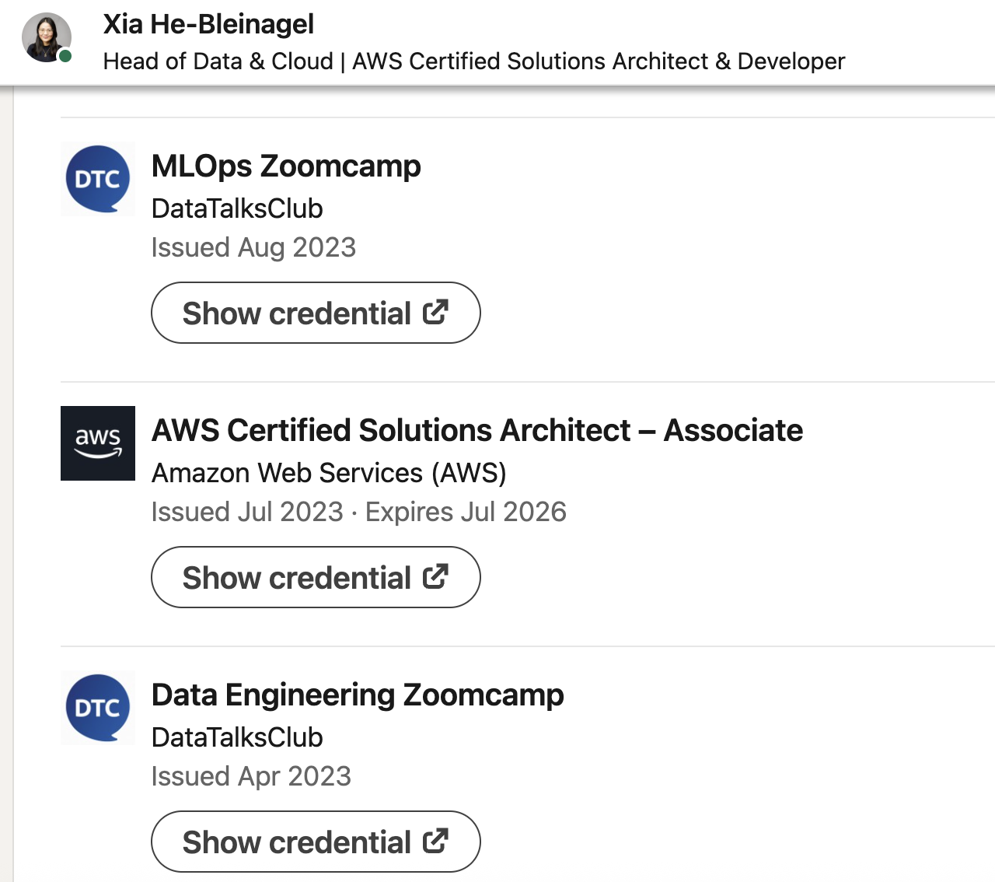

- How do you balance leadership responsibilities with personal life, especially as a mom?

- What advice would you give to women who feel “it’s too late” to start in tech?

- What lessons stand out from your first 100 days as Head of Data and Cloud?

- How can companies better support women and moms in their tech careers?
-Offer flexible hours and remote/hybrid options by default, not as exceptions.
-Ensure women and moms are visible in leadership roles.
- Build Mentorship, Sponsorship
- What role has mentorship or community played in your journey?

Tab for Alexey and DTC Team
From Full-Time Mom to Head of Data and Cloud

Subtitle: How resilience and inclusion shape better teams – Xia He-Bleinagel
We will explore what it means to rebuild a career in technology and grow into leadership after a major life change. The session will look at how resilience, curiosity, and continuous learning can open new paths in data and cloud, especially when re-entering the workforce after time away. Drawing from practical experiences, it will touch on the mindset shifts, support systems, and habits that make career reinvention possible in a fast-moving field.
The conversation will also highlight the human side of leadership that inclusive practices, empathy, and mentorship can help teams perform better and stay connected. It will examine how organizations can better support women and parents in tech, why visibility and representation matter, and what it takes to build confidence and belonging in technical environments.

She will cover:

- Reflections from Xia’s first 100 days as Head of Data and Cloud
- Building a high-performing, empathetic data team
- Returning to tech after a career break and finding confidence
- Empowering women and mothers through inclusion and mentorship

About the Speaker:
Xia He-Bleinagel is Head of Data and Cloud at N O W GmbH, a German federal organization advancing zero-emission mobility and sustainable technology. After taking time off to raise her children, she returned to the workforce and built a successful career in data and cloud engineering.
Through continuous learning and community involvement, she rose to a leadership role where she now focuses on building inclusive teams, empowering women in tech, and leading with empathy.

Links
- LinkedIn: https://www.linkedin.com/in/xia-he-bleinagel-51773585/
- Github: https://github.com/Data-Think-2021
- Website: https://datathinker.de/

Speech
This week we’ll talk about career transitions, leadership, and building inclusive data teams.
We have a special guest today — Xia He-Bleinagel.
Xia is the Head of Data and Cloud at NOW (Please don’t pronounce in English, but each letter in German N O W) GmbH, where she supports Germany’s transition toward zero-emission mobility through data and cloud innovation. Her journey from being a full-time mom to leading a data team is a story of resilience, growth, and inclusion.
Welcome, Xia!
Before we go into our main topic of leadership and inclusion, let’s start with your background. Can you tell us about your career journey so far? (not too long please =))

Questions
Career Journey
- What inspired your transition from being a full-time mom to pursuing a career in tech?
- What were the hardest challenges in the early years, and how did you overcome them?
- You participated in two Zoomcamps in 2023, MLOps and Data Engineering. How did those experiences help you grow?
Leadership & Growth
- How was your transition from an individual contributor to a data leadership role, and what helped you prepare and grow into that position so quickly—just five years after graduation?
- What lessons stand out from your first 100 days as Head of Data and Cloud?
- What does building a “high-performing data team” mean to you, and how do you approach it?
- How do you balance leadership responsibilities with personal life, especially as a mom?
Inclusion & Mentorship
- What advice would you give to women who want to start in tech?
- How can companies better support women and mothers in their tech careers?
- What role has mentorship or community played in your journey?
- When other women hear your story, what do you hope they take away from it?

